

Kingdom of Bahrain
Primary Healthcare Centers

Naraak
Phase 3: Sitemap, Service Flows, User Flows & Low-Fidelity Wireframes

Prepared by
Fatima Yaser Darraj
Eman Yaser Alasaadi
Alya Hasan Aldaka
IT Trainees

Submitted to
Mohamed Ateya Neama

24 August 2026

Document Control

Version History
Version | Date | Author | Change Description
0.1 | 6 Aug 2026 | IT Trainee Team | Initial Phase 3 template created with draft sitemap and one worked flow/wireframe example; pending Phase 2 sign-off.
0.2 | 16 Aug 2026 | IT Trainee Team | Service flows and user-flow decision points completed for all 12 in-scope services. Sitemap structure was finalized at spec level. Visual assets remained to be produced in Figma.
0.3 | 23 Aug 2026 | IT Trainee Team | Adding the Figma diagrams

Table of Contents
Document Control 2
Version History 2
Table of Contents 3
Table of Figures 5
1. Purpose of This Phase 6
2. Information Architecture (Sitemap) 6
2.1 Top-Level Navigation (4-tab bottom nav) 7
2.2 Home Tab (Detailed Content) 7
2.3 Services Tab (Categories) 9
2.4 Top Services Grid (Routing Decision) 9
2.5 Notifications (Routing by Type) 10
2.6 Family Management 10
2.7 Pending Requests 11
2.8 Navigation Principles 11
3. Service Flows 12
3.1 Booking Appointments (Tele / In-Center Path) 12
3.2 Medical Reports (View / Request) 12
3.3 Vaccination Records 13
3.4 Newborn Sehati Card 13
3.5 Change Family Doctor 13
3.6 Electronic Hajj Certificate 14
3.7 Update Residential Address 14
3.8 Mammogram Screening 14
3.9 Request Mobile Unit 15
3.10 Health Fee Exemption Card 15
3.11 Primary HealthCare Research Application 15
3.12 Service Flow Summary Table (all 11 services) 16
4. User Flows & Decision Points 17
4.1 Booking Appointments 17
4.2 Vaccination Records 18
4.3 Medical Reports 18
4.4 Sehati Card Request for Newborns 19
4.5 Electronic Hajj Certificate 19
4.6 Update Residential Address 20
4.7 Health Fee Exemption Card 20
4.8 Request Mobile Unit Service 20
4.9 Mammogram Screening 21
4.10 Change Family Doctor 21
4.11 Primary Healthcare Research Applications 22
5. Low-Fidelity Wireframes 23
5.1 Screen Count Summary 23
5.2 Mobile Version 23
5.3 Web version 29
6. Reference 32

Table of Figures

Figure 1: Naraak Sitemap 6
Figure 2: Naraak Top-Level Navigation 7
Figure 3: Home tab 8
Figure 4: Services Tab 9
Figure 5: Top Services Grid 9
Figure 6 : Notifications Flow 10
Figure 7: Family Management Flow 10
Figure 8: Pending Requests Flow 11
Figure 9: Booking Appointments (Tele / In-Center) Service Flow 12
Figure 10: Medical Reports Service Flow 12
Figure 11: Vaccination Records Service Flow 13
Figure 12: Newborn Sehati Card Service Flow 13
Figure 13: Change Family Doctor Service Flow 13
Figure 14: Electronic Hajj Certificate Service Flow 14
Figure 15: Update Residential Address Service Flow 14
Figure 16: Mammogram Screening Service Flow 14
Figure 17: Request Mobile Unit Service Flow 15
Figure 18: Health Fee Exemption Card Service Flow 15
Figure 19: Primary HealthCare Research Application Service Flow 15
Figure 20: Booking Appointments User Flow 17
Figure 21: Vaccination Records User Flow 18
Figure 22: Medical Reports User Flow 19
Figure 23: Sehati Card Request for Newborns User Flow 19
Figure 24: Electronic Hajj Certificate User Flow 20
Figure 25: Update Residential Address User Flow 20
Figure 26: Health Fee Exemption Card User Flow 20
Figure 27: Request Mobile Unit Service User Flow 21
Figure 28: Mammogram Screening User Flow 21
Figure 29: Change Family Doctor User Flow 21
Figure 30: Primary Healthcare Research Applications User Flow 22
Figure 31: Naraak Welcome and home page 23
Figure 32: Home Page (Pending Requests Section & Family management) 24
Figure 33: Pending Requests (Detailed Page) 24
Figure 34: My Appointments Tab (Booking Tele-appointments Flow) 25
Figure 35: My Appointments Tab (Booking In-Center appointment Flow) 25
Figure 36: Confirm Booking pages 26
Figure 37: All services tab (Newborn Sehati Card & Change family doctor Services) 26
Figure 38: Vaccination Records Service 27
Figure 39: Medical Reports Service 27
Figure 40: Research Application Service 28
Figure 41: Fee Exemption Card Service 28
Figure 42: Other services (Electronic hajj certificate / Update residential address/Request mobile unit/ Mammogram screening) 29
Figure 43: Home Tab 29
Figure 44: Appointments Tab 30
Figure 45: All Services Tab 30
Figure 46: Profile Tab 31

1. Purpose of This Phase
Phase 3 turns the Phase 2 service priorities and personas into structure: how the app is organized (sitemap), how each service works step-by-step (service flows), how the user moves through it (user flows), and rough screen layouts (low-fidelity wireframes). This is still structural, not visual design (colors, typography) and final UI come in Phase 4.
This edition is built on:
- Phase 2 Service Prioritization Matrix (v0.2): originally 12 services in scope; consolidated to 11 in this edition (see Section 2).
- Phase 2 Personas and TO-BE Journey Maps (v0.2): each service flow and user flow below is derived from its corresponding TO-BE journey.
- Phase 1 Prioritized Pain Point Summary and per-service findings (v0.7).
- The built Figma Home/Services screens: this edition reflects the actual navigation structure as built, which supersedes the original priority-tier sitemap concept from v0.1/v0.2.

2. Information Architecture (Sitemap)
The sitemap groups all 11 PHC services and platform-level features under a 4-tab bottom navigation, consistent with Phase 1 finding that PHC services were mixed with hospital/prescription services with no distinction, and the Phase 2 requirement for a single consolidated Naraak entry point (See Figure 1).
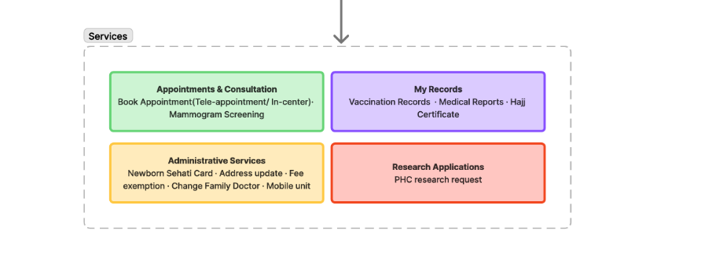
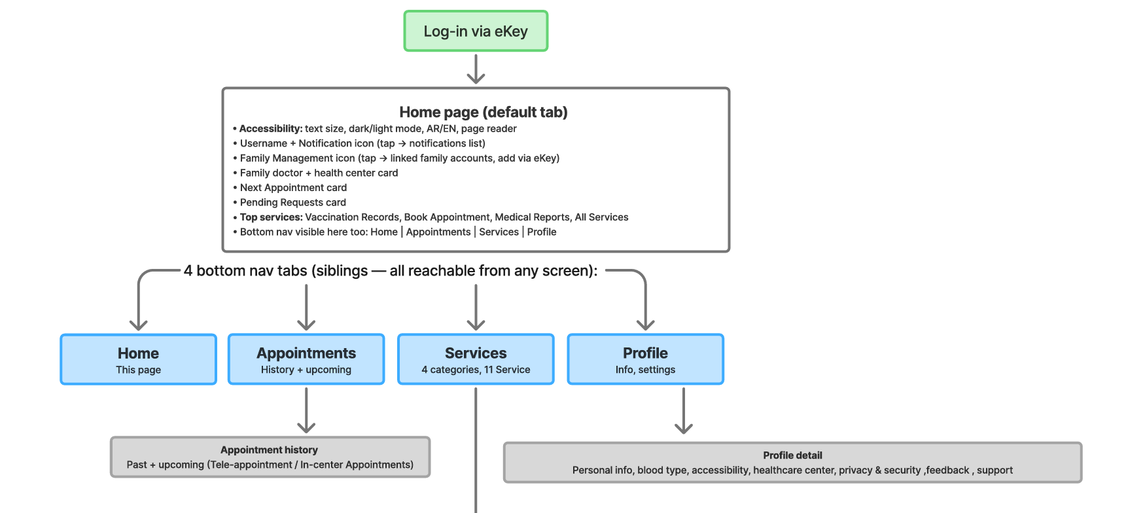

Figure 1: Naraak Sitemap

Note on service count:
- Tele-Appointment is no longer a standalone service; it is a branch inside Booking Appointments (tele vs. in-center choice at entry).
- Missing Vaccination is no longer a standalone service; it is a branch inside Vaccination Records (download vs. missing-record request). This brings the total from 12 to 11 in-scope services.

2.1 Top-Level Navigation (4-tab bottom nav)
- Home dashboard: family doctor, next appointment, pending requests, top services shortcuts, notifications, accessibility settings, family management quick access.
- Appointments: full appointment history, past + upcoming, filterable (includes Tele-Appointment / In-center).
- Services: All 11 services grouped into 4 categories.
- Profile: personal info, blood type, accessibility settings, assigned health center, theme, language, privacy & security, feedback, support (See Figure 2).
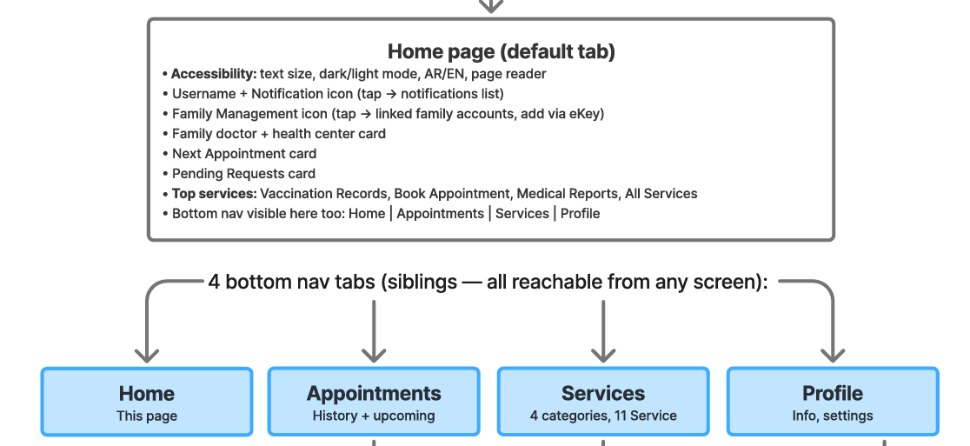
Figure 2: Naraak Top-Level Navigation

2.2 Home Tab (Detailed Content)
- Accessibility controls: text size (A-/A+), dark/light mode toggle, Arabic/English toggle, page-reader icon.
- Username + Notification bell icon → Notifications list (routes by type — see Section 2.5).
- Family Management icon → Linked family accounts list (quick-access).
- Family Doctor card: informational, shows assigned doctor + health center.
- Next Appointment card → Appointment details (includes the Tele-Appointment join/resend flow if the appointment is a video call).
- Pending Requests card (badge: active count + ‘N need your attention’) → Pending Requests screen. This is the ONLY entry point to request tracking.
- Top services grid (2×2): Book Appointment, Medical Reports, Vaccination Records, All Services (see the routing decision in Section 2.4).
- Bottom nav, always visible: Home | Appointments | Services | Profile (See Figure 3).

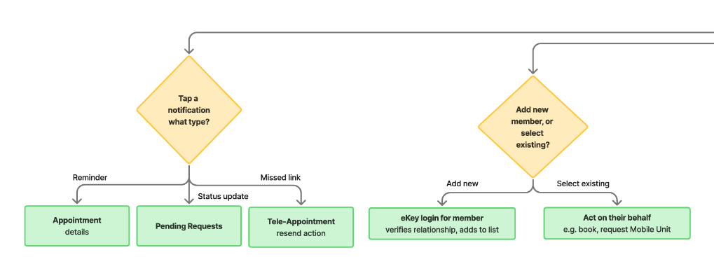
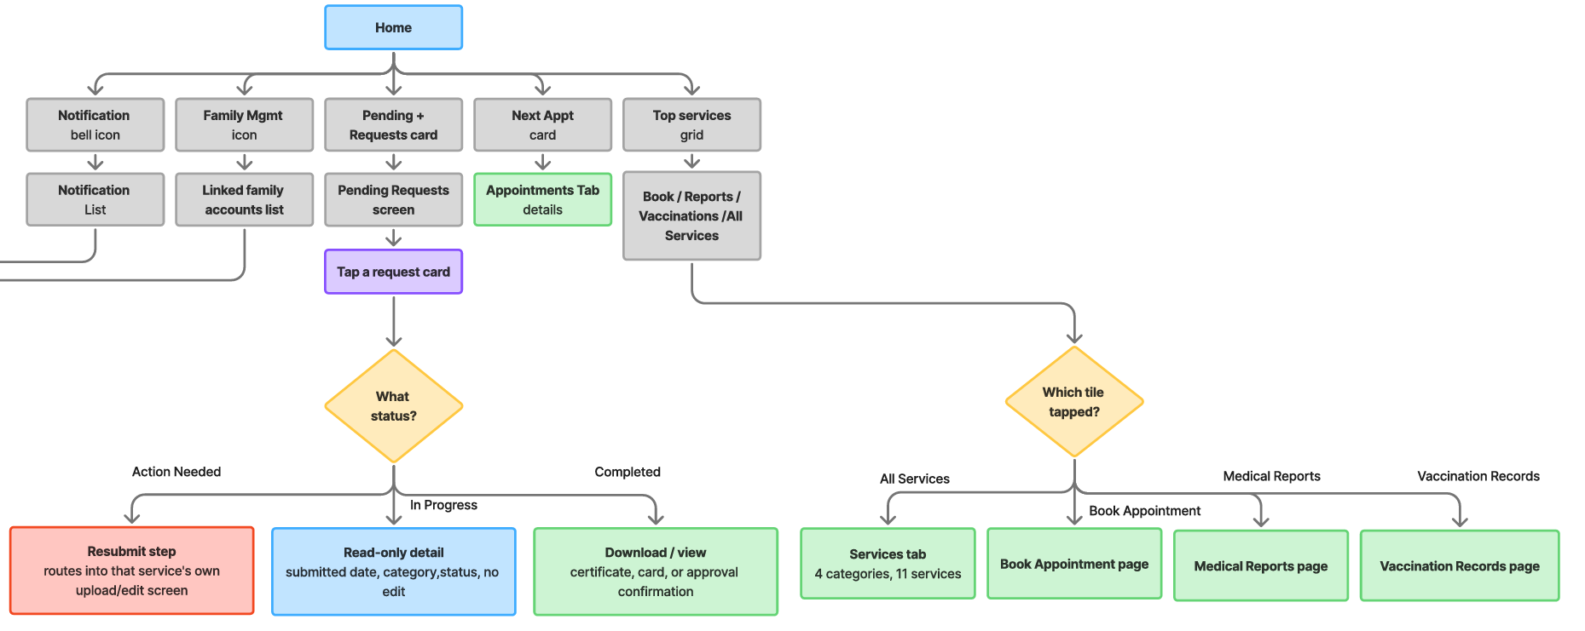
Figure 3: Home tab

2.3 Services Tab (Categories)

Category | Services inside
Appointments & Consultation | Book Appointment (Tele-appointment / In-center) · Mammogram Screening
My Records | Vaccination Records · Medical Reports · Hajj Certificate
Administrative Services | Newborn Sehati Card · Address Update · Fee Exemption Card· Change Family Doctor · Mobile Unit
Research Applications | PHC Research Application
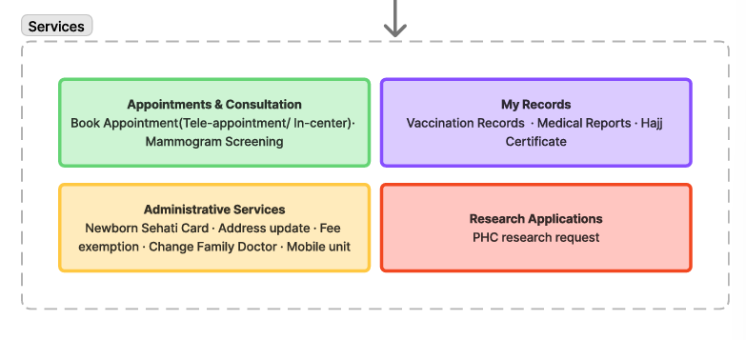
Figure 4: Services Tab

2.4 Top Services Grid (Routing Decision)
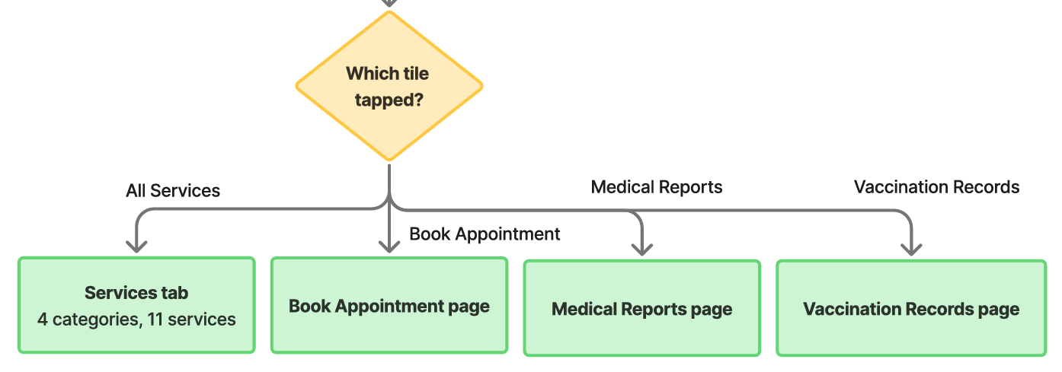
The three named tiles (Book Appointment, Medical Reports, Vaccination Records) route directly to that service’s own entry screen, a 1-tap shortcut that bypasses the Services tab entirely. Only the ‘All Services’ tile routes into the Services tab itself.
Figure 5: Top Services Grid

2.5 Notifications (Routing by Type)
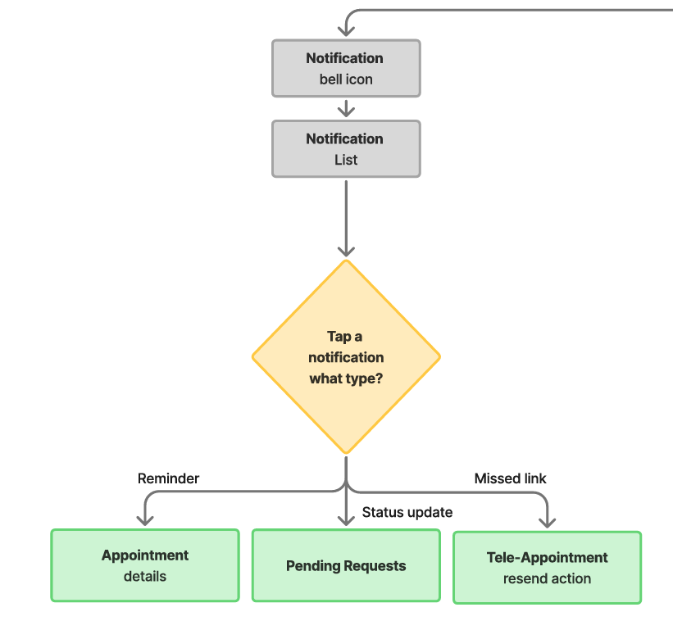
Notifications are not a flat list, tapping one routes differently depending on its type.
Figure 6 : Notifications Flow

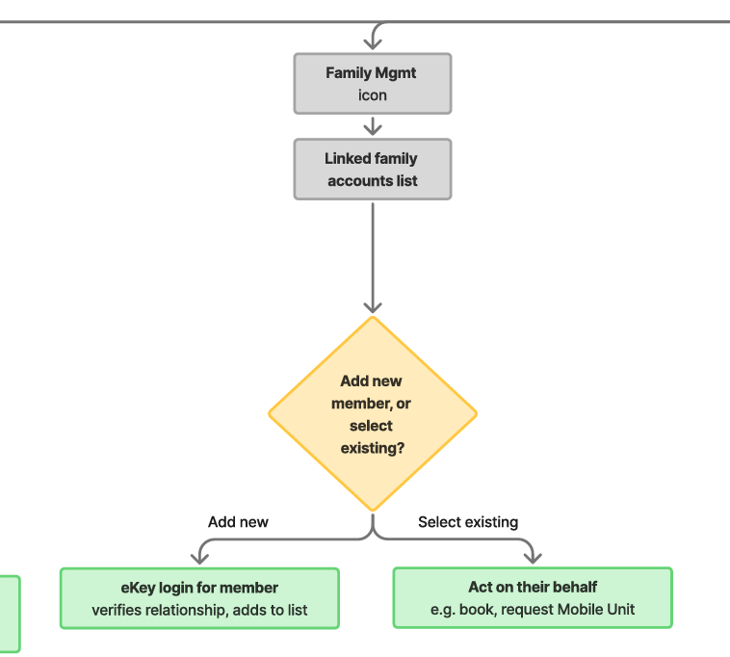
2.6 Family Management
Figure 7: Family Management Flow

2.7 Pending Requests
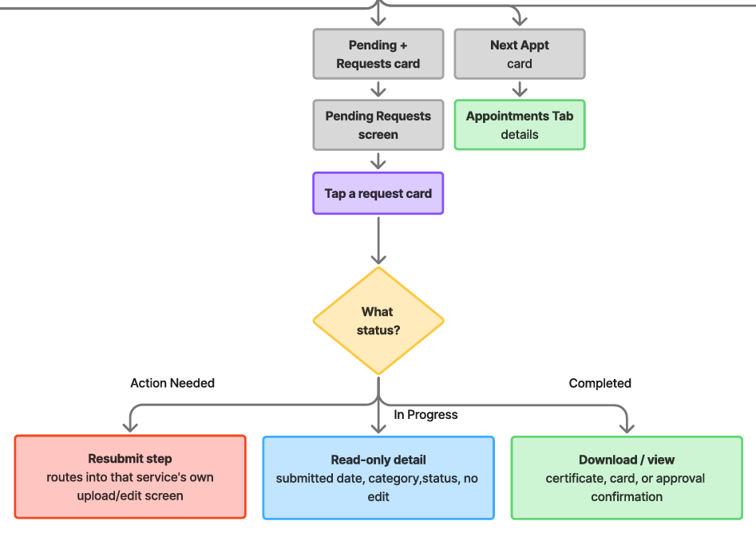
Home-only (see 2.2). Filter tabs: All / In Progress / Completed / Action Needed.
Figure 8: Pending Requests Flow

2.8 Navigation Principles
- Bottom navigation is limited to the 4 tabs above (mobile); same structure mirrors to a top nav on web.
- PHC services are grouped under a single ‘Services’ entry point, resolving the Phase 1 finding that PHC services were mixed with general hospital services.
- Family Management is reachable in one tap from Home (quick access) and fully manageable from any page.
- Request tracking (Pending Requests) is deliberately Home-only, not duplicated into Services, to keep Home as the single dashboard for anything time-sensitive.
- Max 2-tap depth to any service still holds for everything reached via Services → category → service; the Top Services grid shortcuts three of the highest-traffic services to 1 tap.

3. Service Flows
A service flow documents the backend/process logic of a single service end-to-end, shown as a 4-lane swimlane: Patient · Naraak App (frontend) · Backend API · External System (RMS / eKey / MOH DB / CIO registry / Notification Service). This is distinct from the user flow (Section 4), which shows only what the patient taps through.

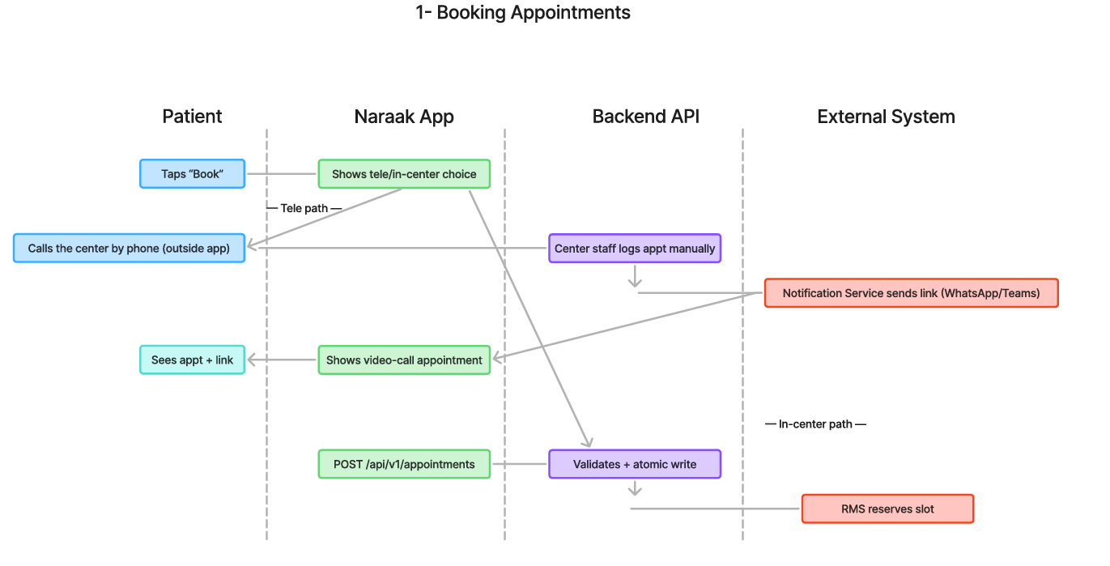
3.1 Booking Appointments (Tele / In-Center Path)
Step | Screen / Touchpoint | User Action | System Response
1 | Services › Booking entry | Taps ‘Book Appointment’, chooses Tele or In-center, then Dental or General | Loads the 3 in-center booking paths
2 | Results list | Picks Path A/B/C, filters by doctor/time | Real-time slot list from RMS
3 | Slot selection | Selects a slot, taps Confirm | POST /api/v1/appointments (atomic write, RMS reserves the slot)
4 | Confirmation | Confirms booking | Appointment created; Notification Layer triggers confirmation + reminder
Figure 9: Booking Appointments (Tele / In-Center) Service Flow

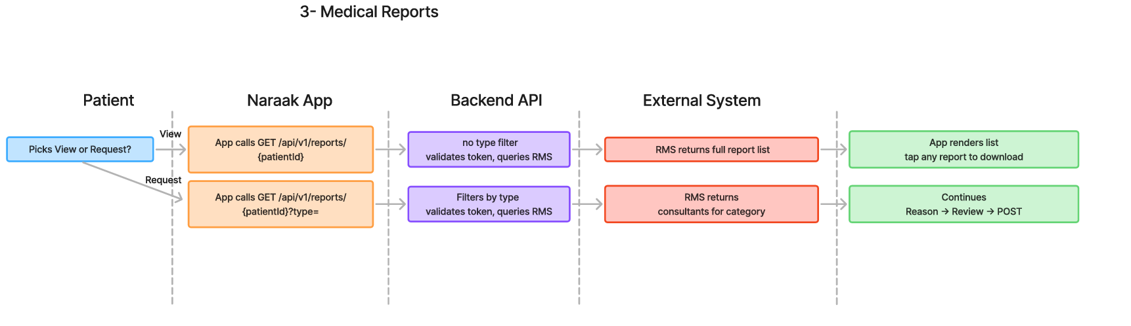
3.2 Medical Reports (View / Request)
Figure 10: Medical Reports Service Flow

3.3 Vaccination Records
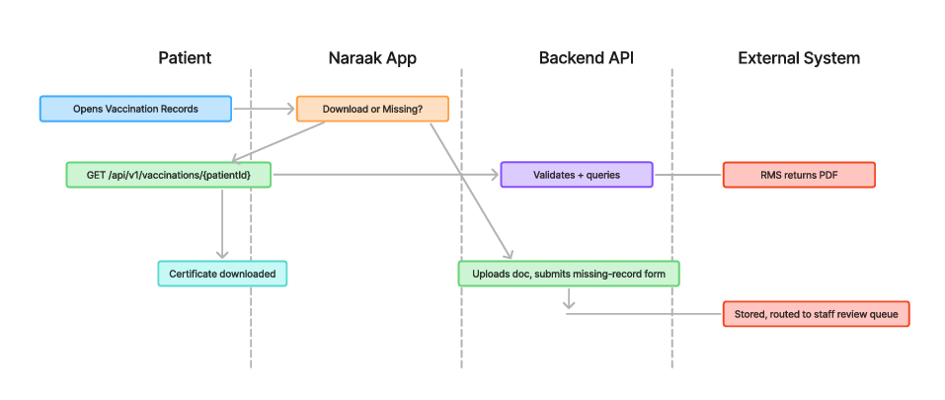
Figure 11: Vaccination Records Service Flow

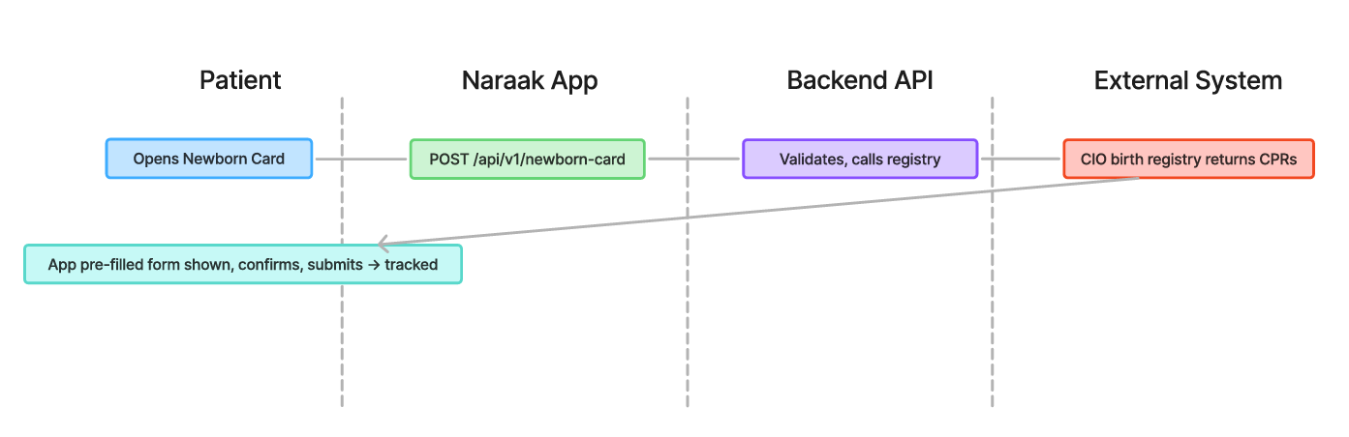
3.4 Newborn Sehati Card
Figure 12: Newborn Sehati Card Service Flow

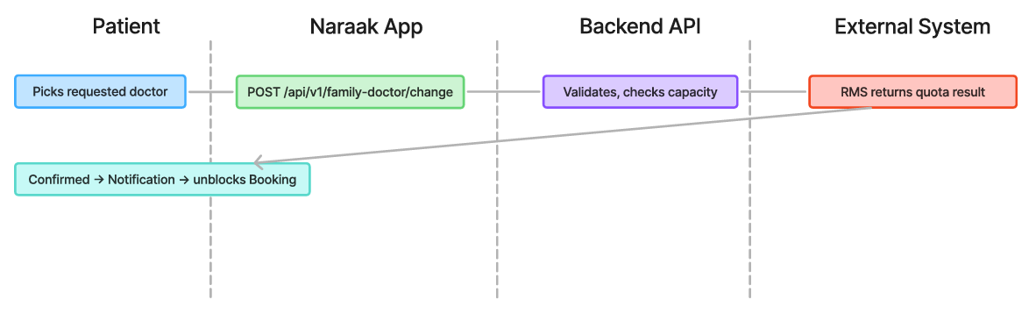
3.5 Change Family Doctor
Figure 13: Change Family Doctor Service Flow

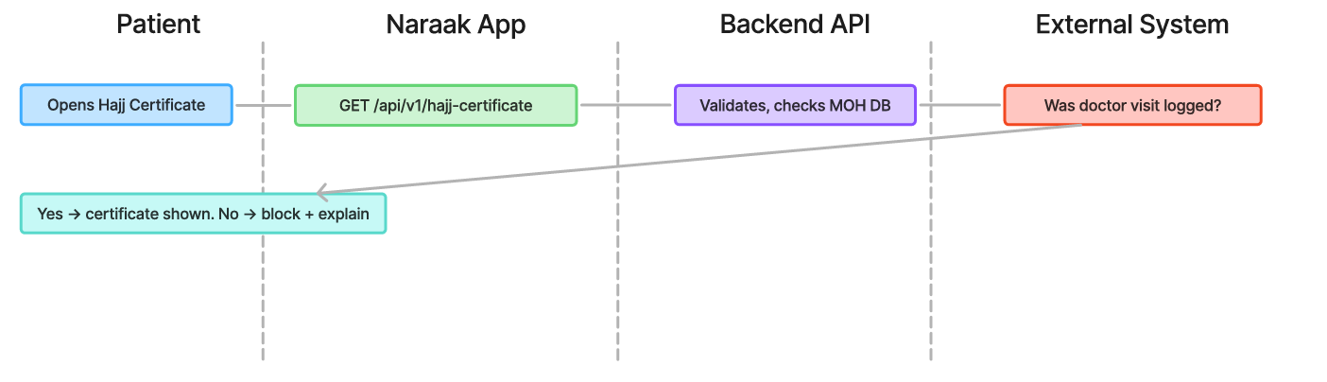
3.6 Electronic Hajj Certificate
Figure 14: Electronic Hajj Certificate Service Flow

3.7 Update Residential Address
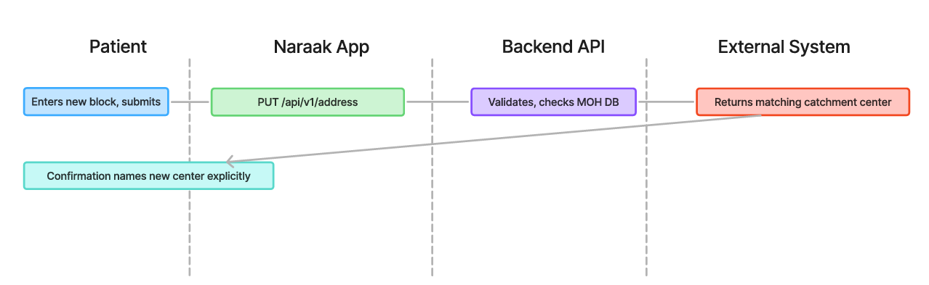
Figure 15: Update Residential Address Service Flow

3.8 Mammogram Screening

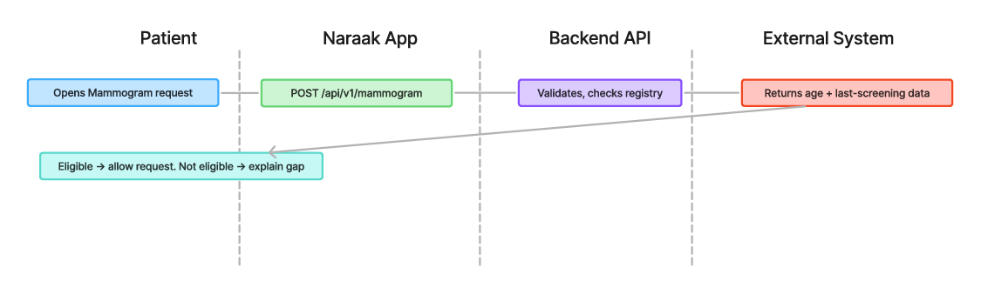
Figure 16: Mammogram Screening Service Flow

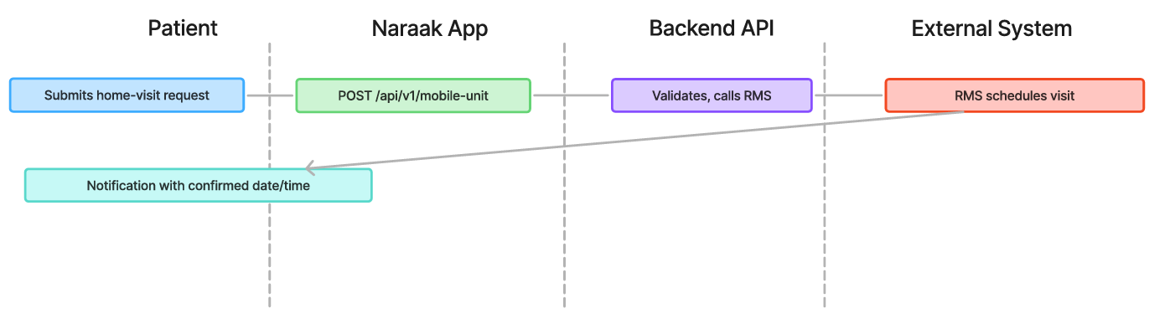
3.9 Request Mobile Unit
Figure 17: Request Mobile Unit Service Flow

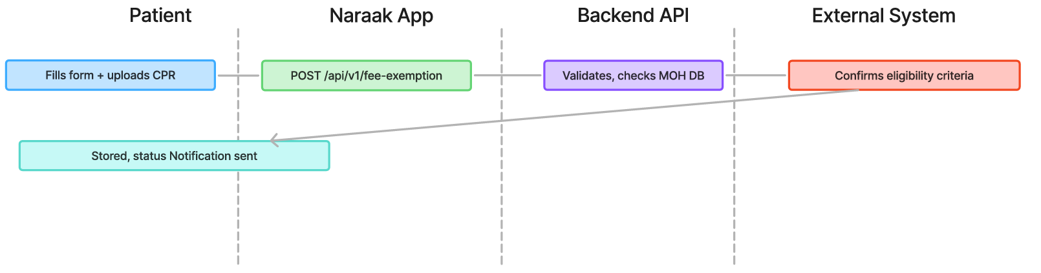
3.10 Health Fee Exemption Card
Figure 18: Health Fee Exemption Card Service Flow

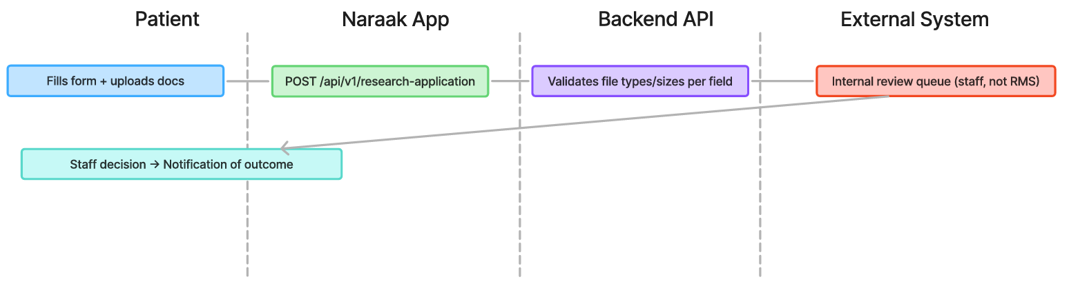
3.11 Primary HealthCare Research Application
Figure 19: Primary HealthCare Research Application Service Flow

3.12 Service Flow Summary Table (all 11 services)
Endpoints marked ‘add’ are logical extensions following the existing /api/v1/ pattern, not yet formally specified in the main proposal’s illustrative table.
Naraak App calls | Backend API | External System | Notification trigger
POST /api/v1/appointments (in-center) — tele path has no formal endpoint, staff-driven | Validates token, atomic write | RMS (slot reserve) — tele: none (phone call) | Confirmation + reminder; tele: link via WhatsApp/Teams
GET /api/v1/vaccinations/{patientId} (download) — missing path has no GET, upload only | Validates token, queries RMS | RMS (vaccination data) | None for download; missing-record routes to staff review queue
View: GET /api/v1/reports/{patientId} (no filter) — NEW. Request: GET /api/v1/reports/{patientId}?type= | View: no type filter. Request: filters by type | RMS (full list for View; consultants for Request) | Notification when a requested report/excuse is ready
Add — POST /api/v1/newborn-card | Validates token, calls registry | CIO birth registry (auto-fill CPRs) | Notification on card issuance
Add — GET/POST /api/v1/hajj-certificate | Validates token, checks MOH DB | MOH patient DB (doctor-visit verification) | Notification when certificate ready
Add — PUT /api/v1/address | Validates token, checks MOH DB | MOH patient DB (catchment reassignment) | Notification confirming new health center
Add — POST /api/v1/fee-exemption | Validates token, checks MOH DB | MOH patient DB (eligibility + docs) | Status notification
Add — POST /api/v1/mobile-unit | Validates token, calls RMS | RMS (scheduling) | Notification with visit date/time
Add — POST /api/v1/mammogram | Validates token, checks registry | MOH/RMS (eligibility registry check) | Reminder ahead of scheduled appointment
POST /api/v1/family-doctor/change | Validates token, checks RMS capacity | RMS (doctor capacity check) | Notification on approval; unblocks Booking
Add — POST /api/v1/research-application | Validates each field’s file type/size | Internal review queue (staff, not RMS) | Notification of review outcome

4. User Flows & Decision Points
A user flow shows only what the patient taps through screens in order, with decision points branching to their Yes/No or alternate outcomes. Each service below lists its screens, its decision-point table (where applicable), and a FigJam diagram.

4.1 Booking Appointments
Screens:
- Book entry → Tele or In-center choice → (in-center) Dental or General Clinic → Path A/B/C → Confirm booking → My Appointments (status).
- Tele path: Instructions + Book button → Link accessible in Appointments → Link missed? decision → Join tapped → short instructions screen (‘opens WhatsApp video call or Teams’) → call.
Figure 20: Booking Appointments User Flow
Decision Point | If Yes | If No / Alternate
Slots available for selected filters? | Proceed | Empty state + nearest alternative
User has registered family doctor? | Pre-filter to that doctor | Show all doctors at center
Reschedule of existing appointment? | Auto-cancel old slot on confirm | Create new
Booking failed (timeout)? | — | Retry + alternative slot suggestion
Tele: original join-link notification missed? | Resend button | Proceed to Join → instructions screen
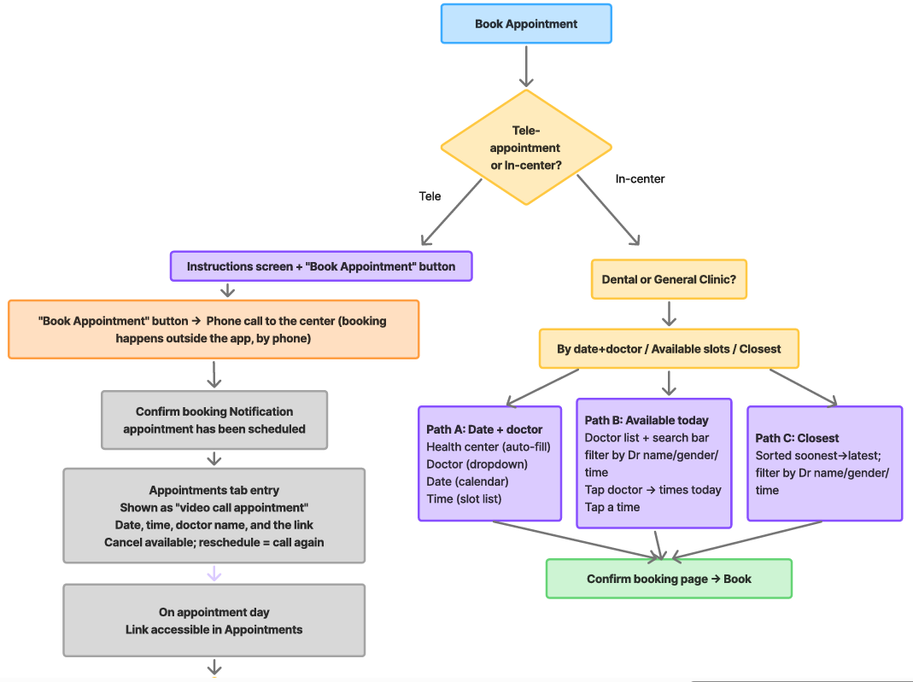
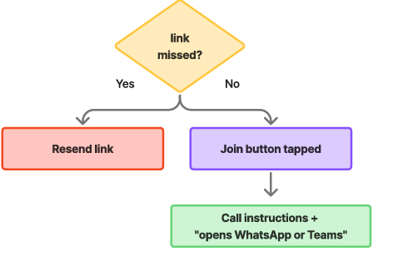

4.2 Vaccination Records
Screens: Vaccination Records entry → Download or Missing Vaccination request? → Download: PDF, no form. Missing: Name + personal number (auto-fill) → Upload document + comments (optional) → Contact (auto-fill, editable) → Submit → tracked in Pending Requests.
Decision Point | If Yes | If No / Alternate
Uploaded file valid type/size? | Accept | Compress to fit the size
Session timed out mid-upload? | — | Restore in-progress form state, don’t clear
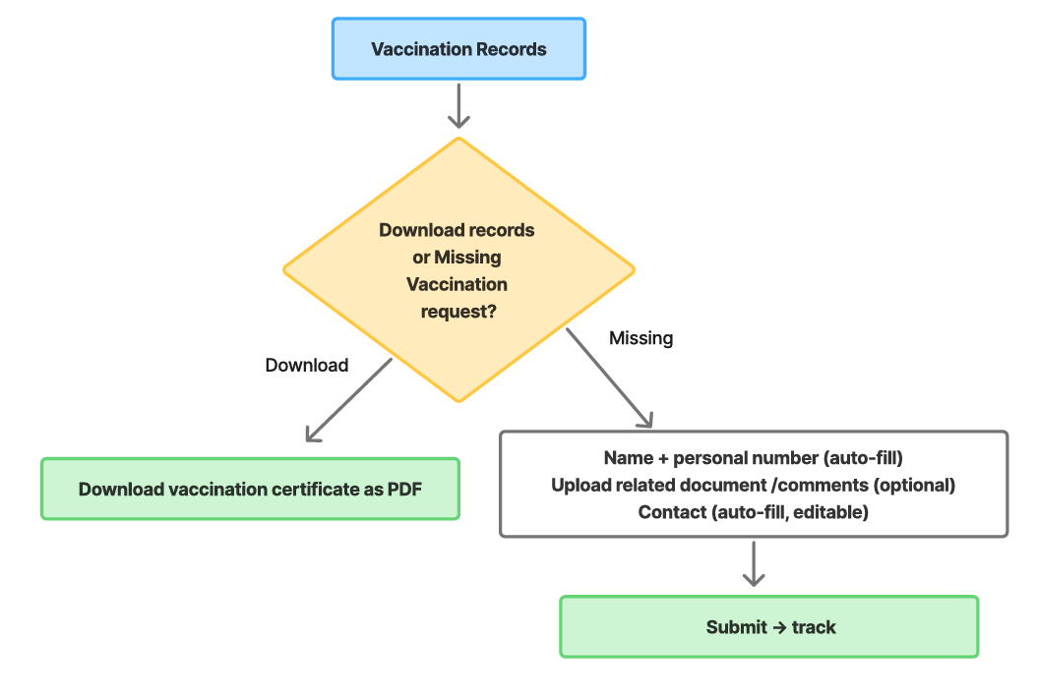
Figure 21: Vaccination Records User Flow

4.3 Medical Reports
Screens: Medical Reports entry → View reports or Request a report? → View: All PHC reports list → tap any to download. Request: Category/Specialty selector → Consultant dropdown (filtered) → Reason + contact (auto-fill, editable) → Review screen → Submit → tracked.
Decision Point | If Yes | If No / Alternate
View reports or Request a report? | View: All PHC reports list, tap to download | Request: continues into the form below
Category has consultants on file? | Populate dropdown | Empty state, suggest a different category

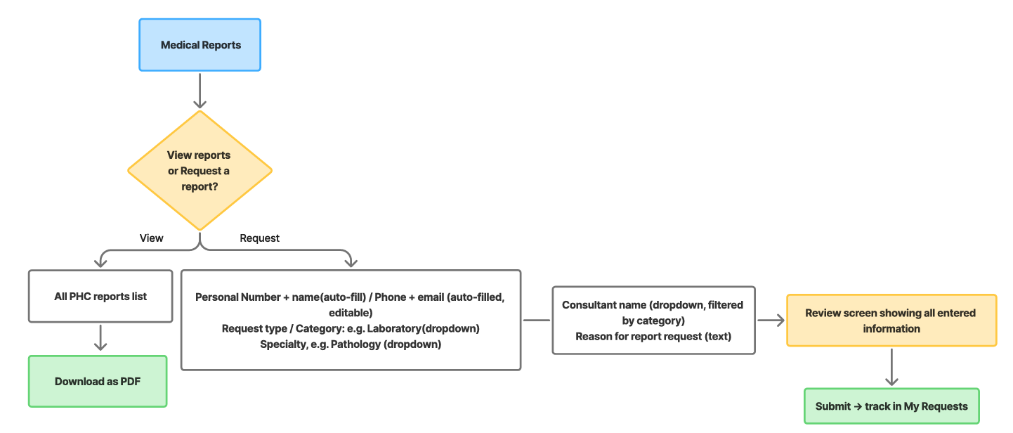
Figure 22: Medical Reports User Flow

4.4 Sehati Card Request for Newborns
Screens: Newborn Sehati Card entry → Reference number (auto-fill) → Newborn/Father/Mother CPR (required) → Block (required) → Submit → tracked.
Decision Point | If Yes | If No / Alternate
Newborn CPR matches birth registry? | Auto pre-fill | Manual entry + notice
Request already submitted for this newborn? | Show existing status | Allow new request
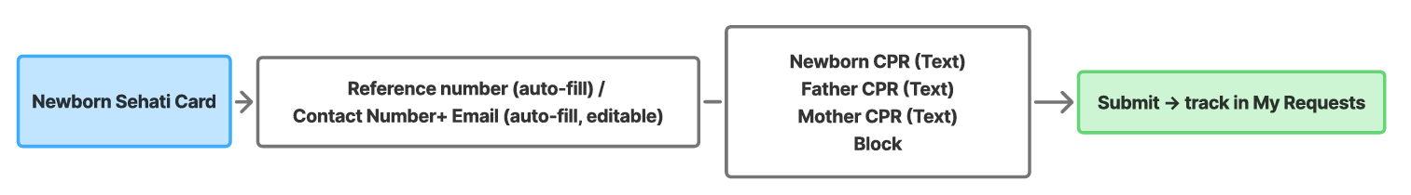
Figure 23: Sehati Card Request for Newborns User Flow

4.5 Electronic Hajj Certificate
Screens: Service info screen (states in-person prerequisite) → Already requested/completed with doctor before? → No: ‘No download available yet’ message. Yes: certificate shown → download.
Decision Point | If Yes | If No / Alternate
Already requested/completed with doctor before? | Certificate shown → download | ‘No download available yet’, no form to fill
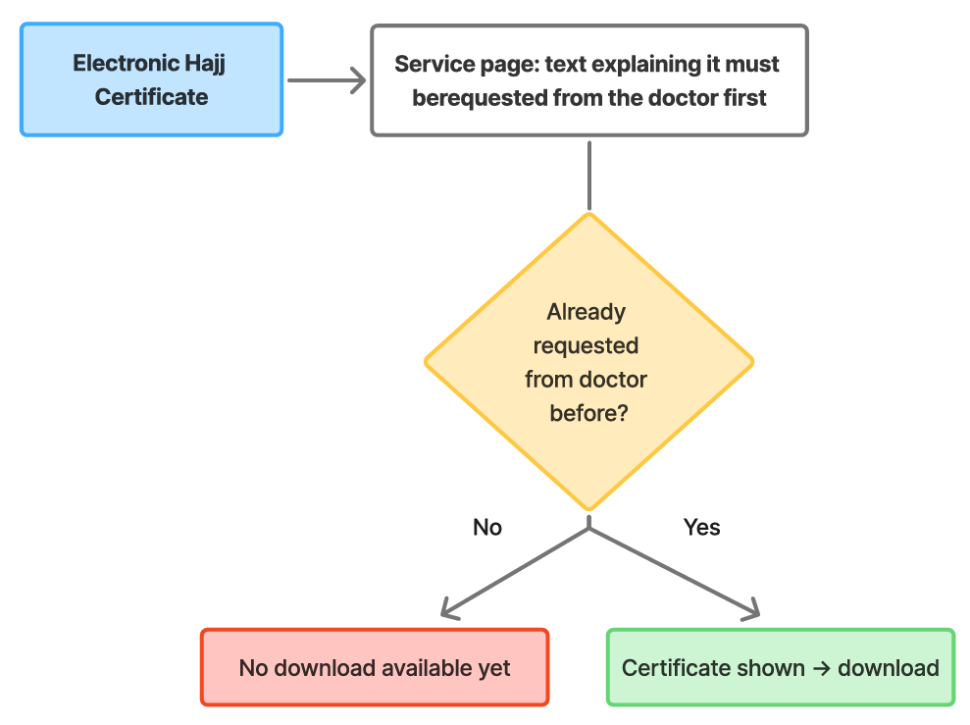
Figure 24: Electronic Hajj Certificate User Flow

4.6 Update Residential Address
Screens: Update Address entry → Reference number + Requester CPR (auto-fill) → Previous block (auto-fill) + New block (required) → Confirm checkbox → Submit → tracked. Confirmation names the new health center.
Figure 25: Update Residential Address User Flow

4.7 Health Fee Exemption Card
Screens: Fee Exemption entry → Reference number (auto-fill) → Gender, Nationality, Request type, Marital status, Spouse nationality → Contact (auto-fill, editable) → Case description → Uploads (CPR, Residence Permit, and conditional documents) → Submit → tracked.
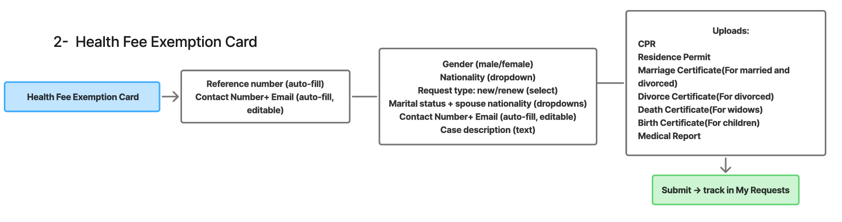
Figure 26: Health Fee Exemption Card User Flow

4.8 Request Mobile Unit Service
Screens: Mobile Unit entry → Reference + Patient CPR (auto-fill) → Contact number (auto-fill, editable) → Patient block number + address (required) → Reason for visit (required) → Submit → tracked.
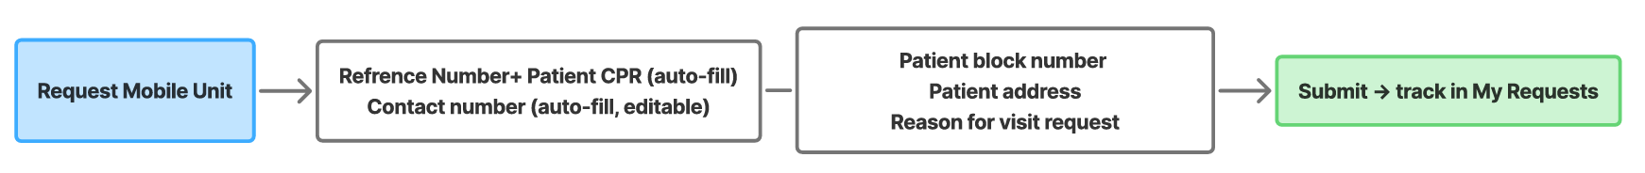
Figure 27: Request Mobile Unit Service User Flow

4.9 Mammogram Screening
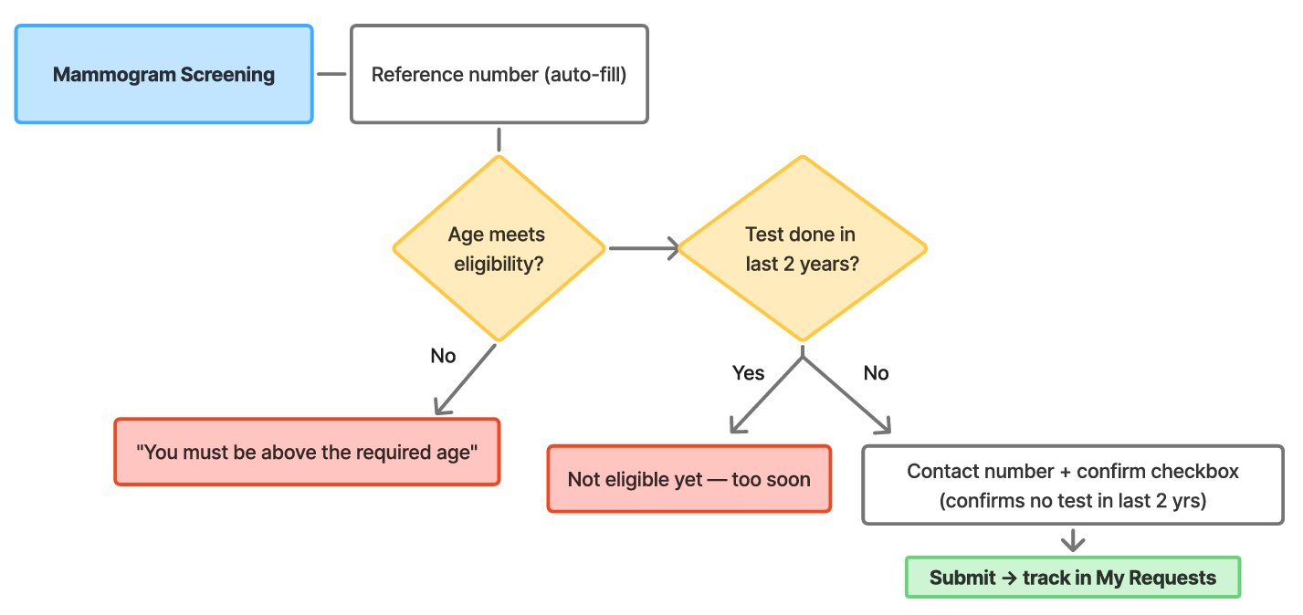
Screens: Mammogram entry → Reference number (auto-fill) → Age meets eligibility? → Test done in last 2 years? → Contact name + confirm checkbox → Submit → tracked.
Figure 28: Mammogram Screening User Flow
Decision Point | If Yes | If No / Alternate
Age meets eligibility? | Continue | ‘You must be above the required age’, stop
Test done in last 2 years? | ‘Not eligible yet, too soon’, stop | Continue to contact + confirm + submit

4.10 Change Family Doctor
Screens: Change Family Doctor entry → Reference number + Patient CPR + name, Current health center + current doctor (auto-fill) → Requested doctor dropdown + reason → Confirm checkbox → Submit → tracked. Approval unblocks Booking.
Decision Point | If Yes | If No / Alternate
Selected doctor has available quota? | Confirm reassignment | Show unavailable + suggest others with open capacity
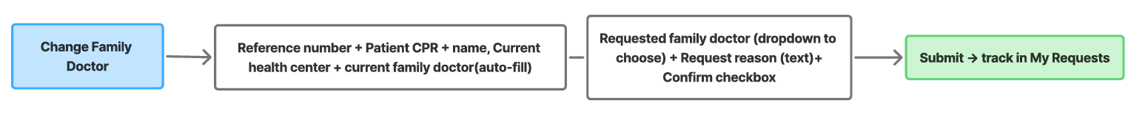
Figure 29: Change Family Doctor User Flow

4.11 Primary Healthcare Research Applications
Screens: Researcher/Student entry (visually separate) → Applicant type select → Reference/email/mobile (auto-fill) → Institution/research details → Uploads (type/size shown per field) → Confirm checkbox → Submit → tracked.
Decision Point | If Yes | If No / Alternate
Uploaded document meets stated type/size for that field? | Accept | Reject inline with the exact accepted type/size shown
Review decision made? | Notify applicant of outcome | Keep ‘Under review’, visible to staff
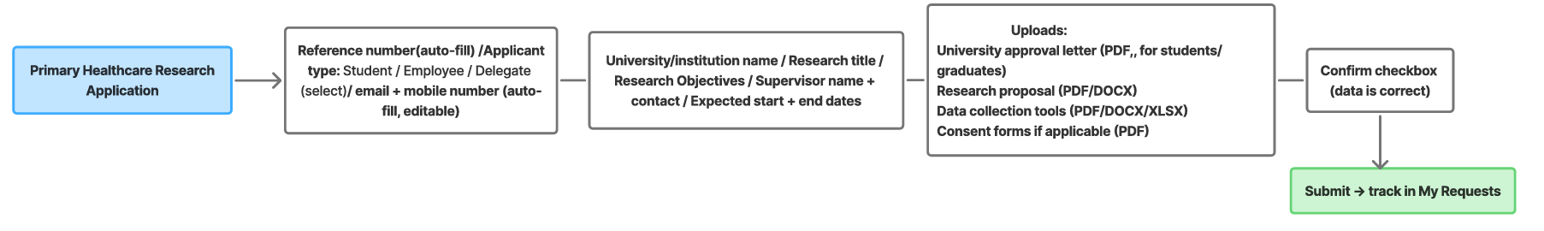
Figure 30: Primary Healthcare Research Applications User Flow

5. Low-Fidelity Wireframes
Low-fidelity wireframes are rough, grayscale layouts that confirm structure and content placement before visual design begins in Phase 4.

5.1 Screen Count Summary
Service / Section | Screens Identified | Wireframes Drafted | Reviewed
Foundation (Login, Home, Notifications, Family Mgmt, Pending Requests ×4, Appointments tab, Services tab, Profile) | 11 | Pending Figma | Pending
Booking Appointments (incl. Tele sub-flow) | 9 | Pending Figma | Pending
Vaccination Records | 3 | Pending Figma | Pending
Medical Reports | 5 | Pending Figma | Pending
Sehati Card for Newborns | 1 | Pending Figma | Pending
Change Family Doctor | 1 | Pending Figma | Pending
Electronic Hajj Certificate | 1 | Pending Figma | Pending
Update Residential Address | 1 | Pending Figma | Pending
Health Fee Exemption Card | 2 | Pending Figma | Pending
Request Mobile Unit | 1 | Pending Figma | Pending
Mammogram Screening | 2 | Pending Figma | Pending
Primary Healthcare Research Application | 3 | Pending Figma | Pending
Total | 40

Note: The total number of screens is subject to change, with additional screens likely to be added as development continues.

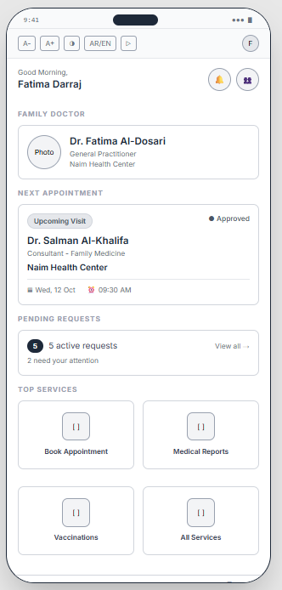
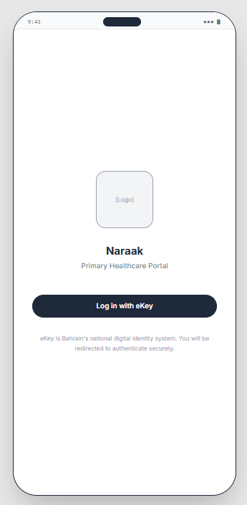
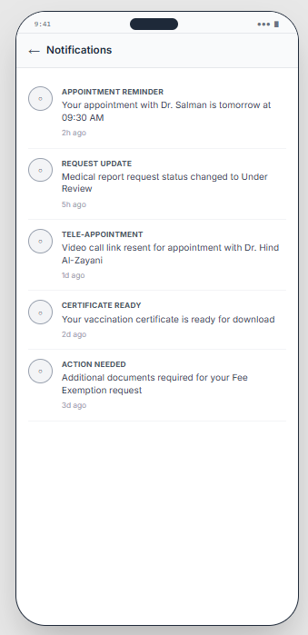
5.2 Mobile Version
Figure 31: Naraak Welcome and home page
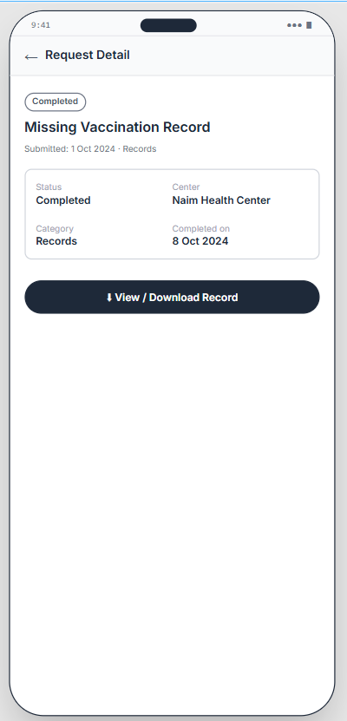
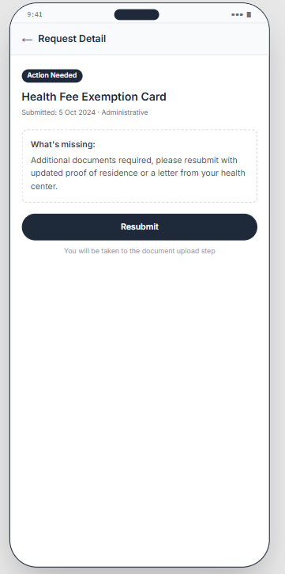
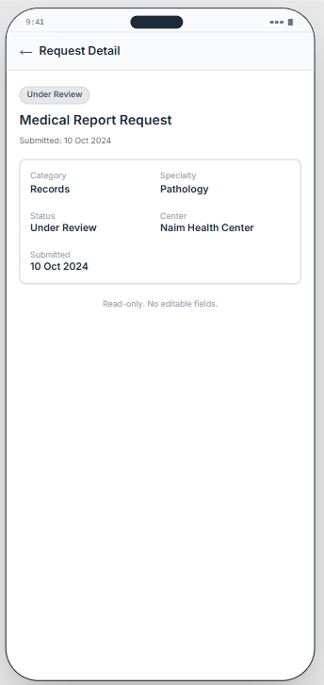
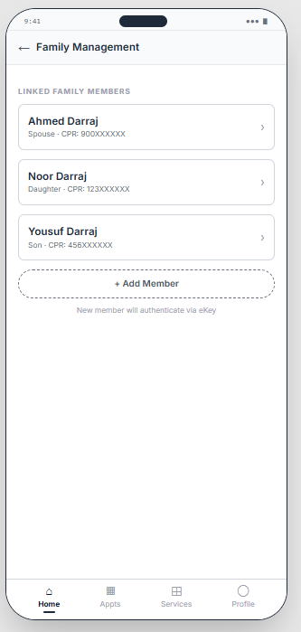
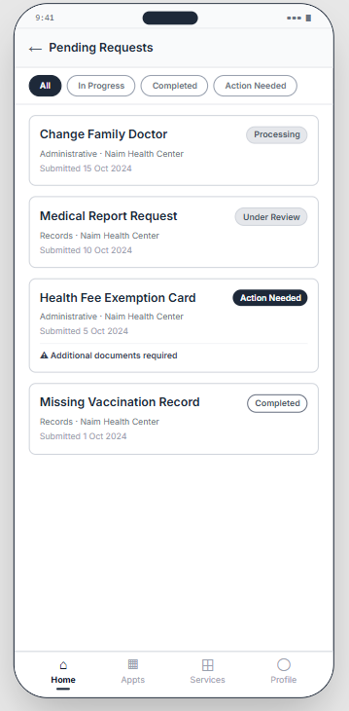
Figure 32: Home Page (Pending Requests Section & Family management)

Figure 33: Pending Requests (Detailed Page)

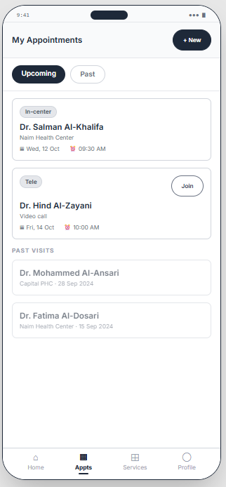
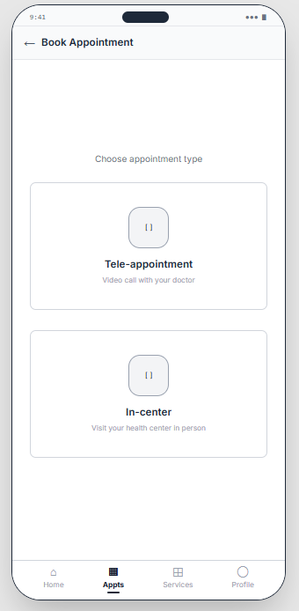
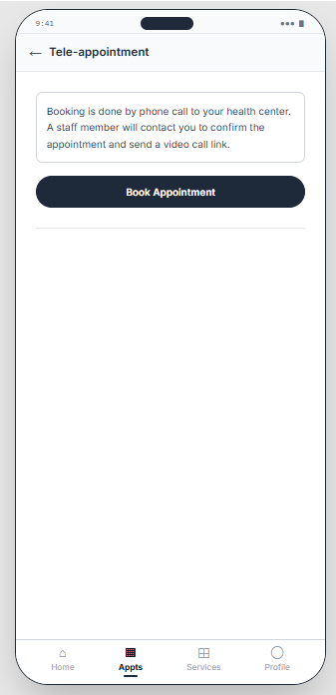
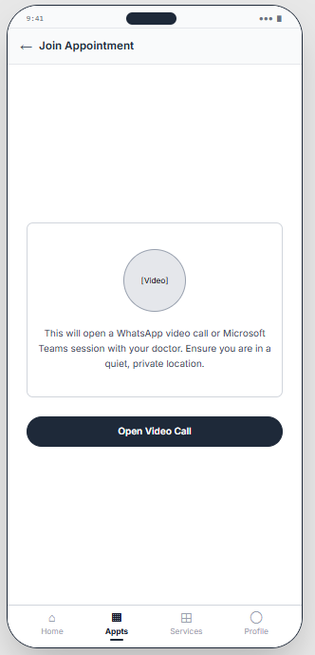
Figure 34: My Appointments Tab (Booking Tele-appointments Flow)
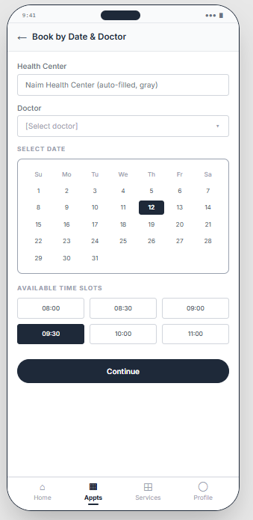
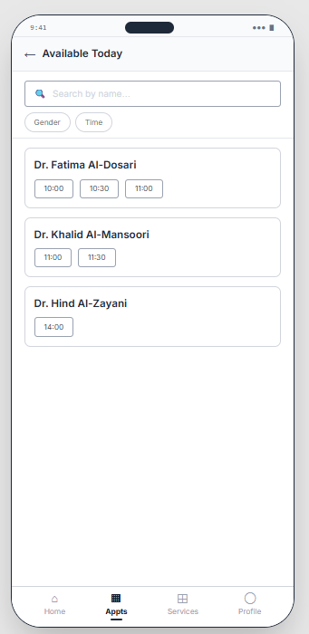
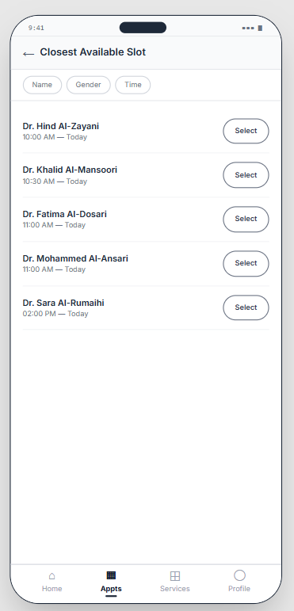
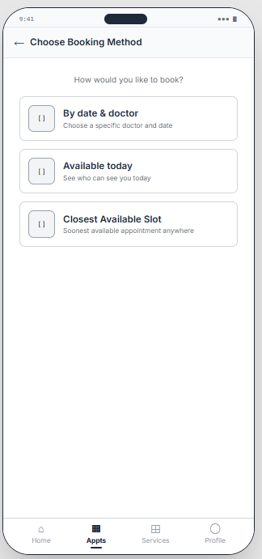
Figure 35: My Appointments Tab (Booking In-Center appointment Flow)

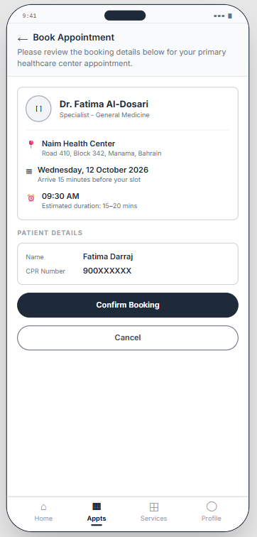
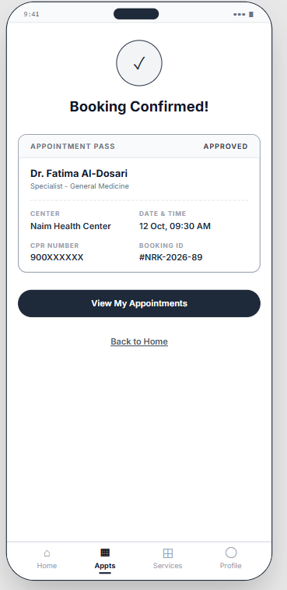
Figure 36: Confirm Booking pages

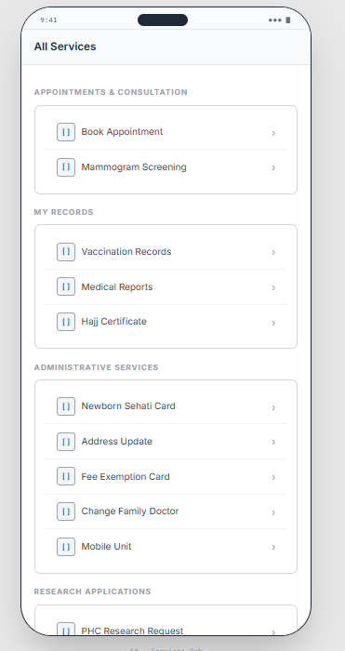
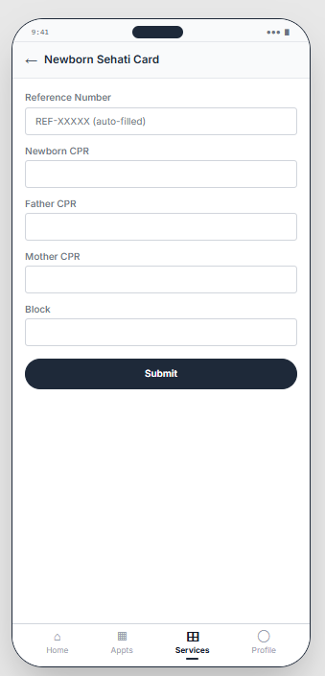
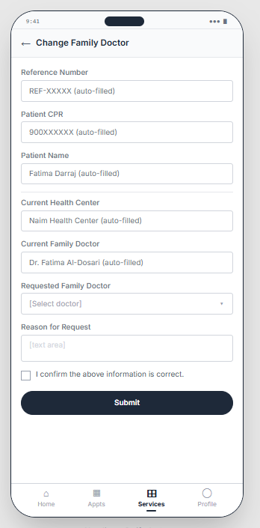
Figure 37: All services tab (Newborn Sehati Card & Change family doctor Services)

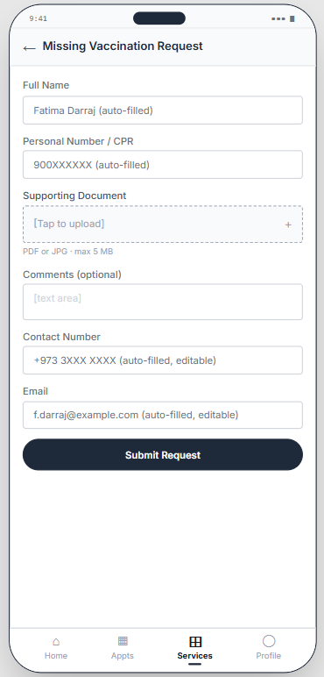
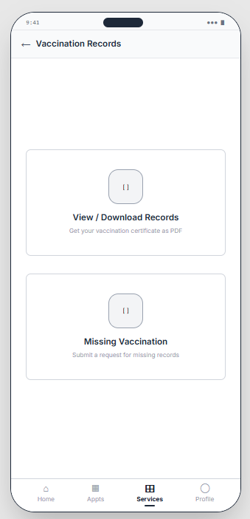
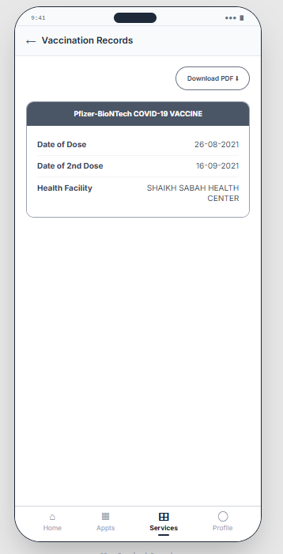
Figure 38: Vaccination Records Service
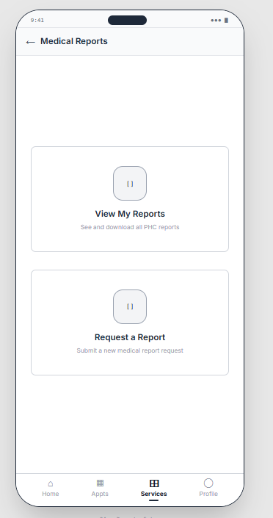
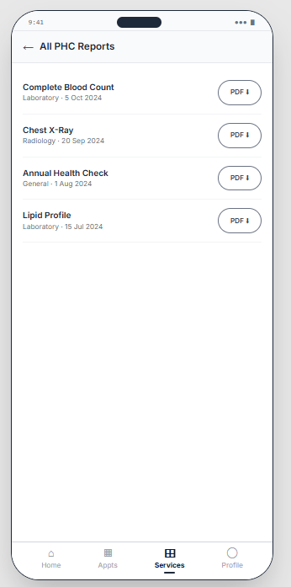
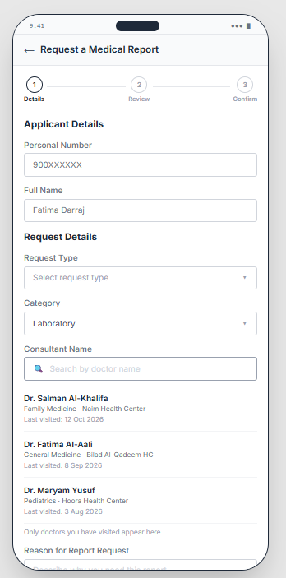
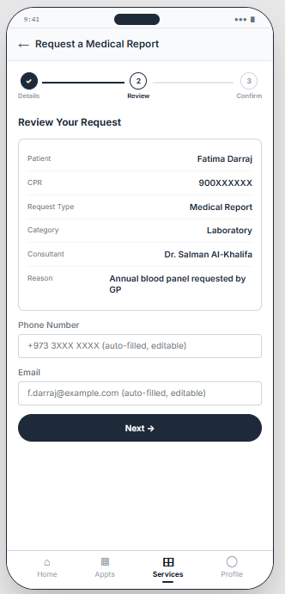
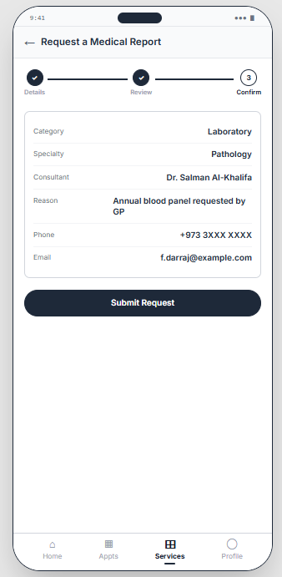
Figure 39: Medical Reports Service

Figure 40: Research Application Service
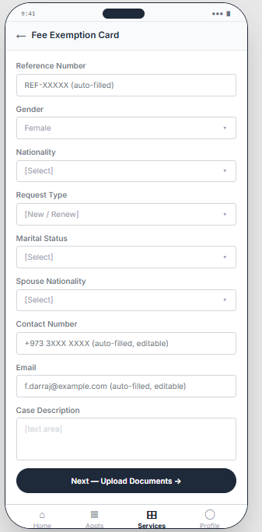
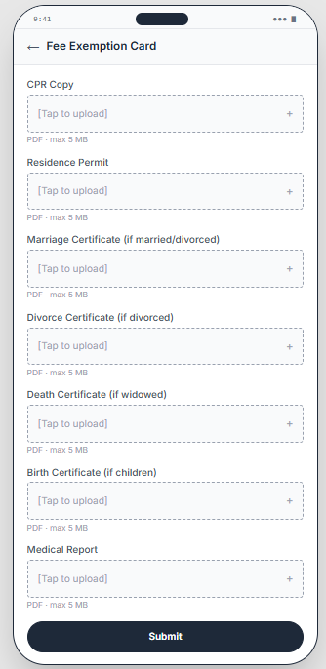
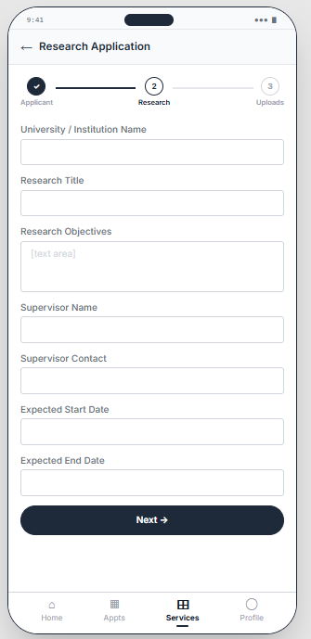
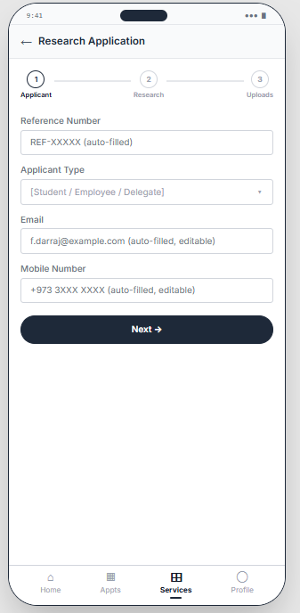
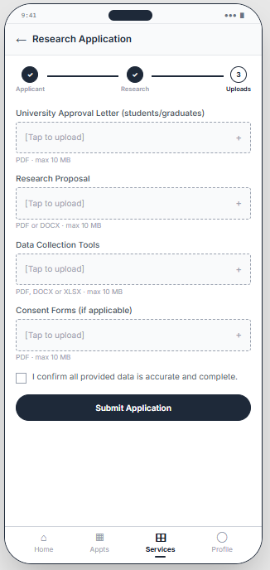

Figure 41: Fee Exemption Card Service
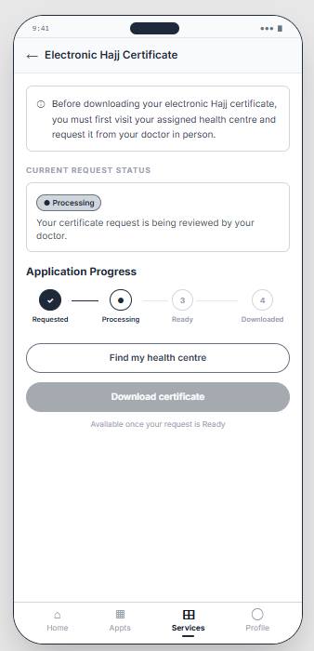
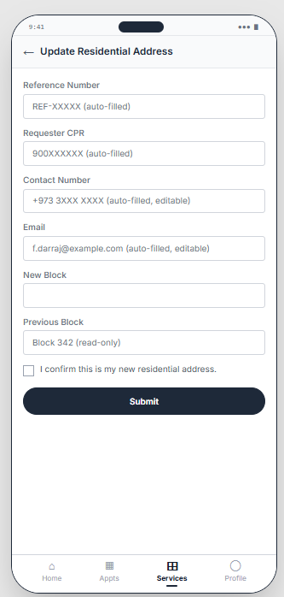
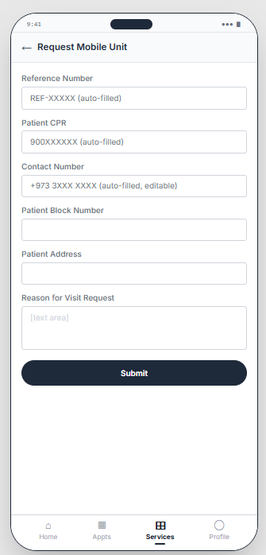
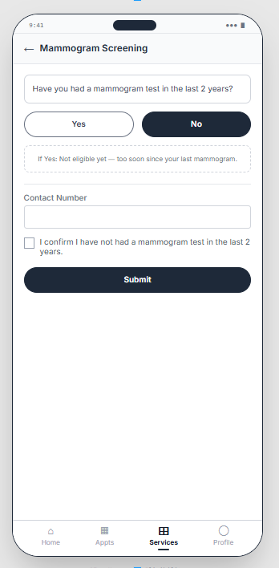
Figure 42: Other services (Electronic hajj certificate / Update residential address/Request mobile unit/ Mammogram screening)

5.3 Web version
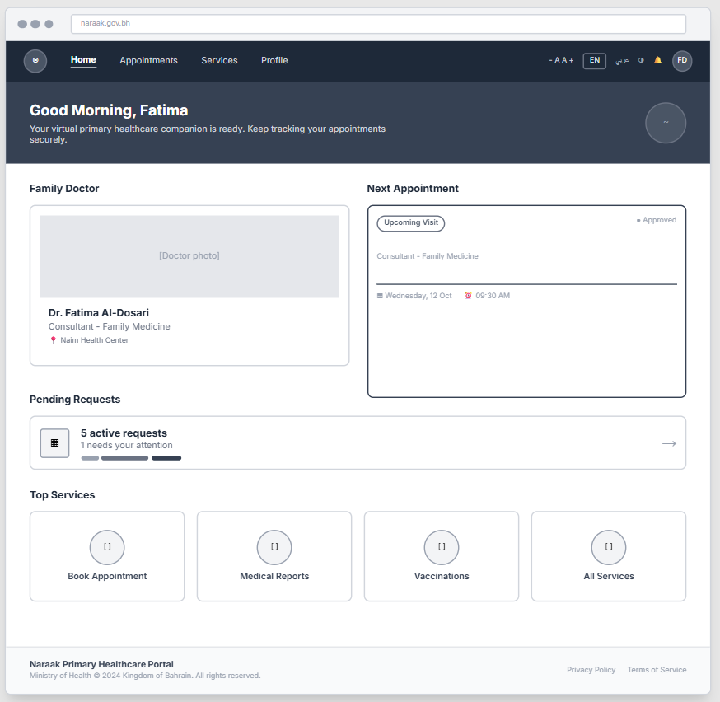
Figure 43: Home Tab
Figure 44: Appointments Tab
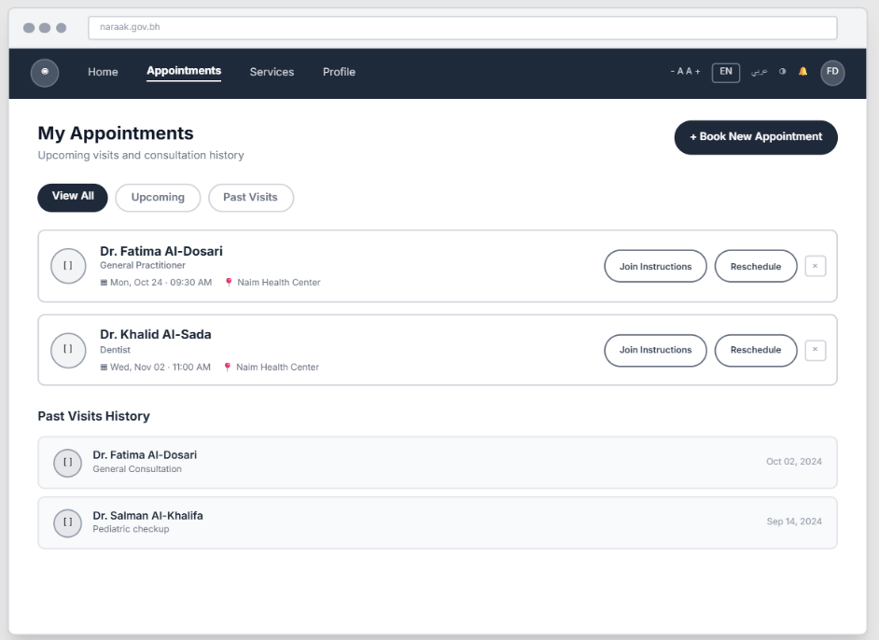
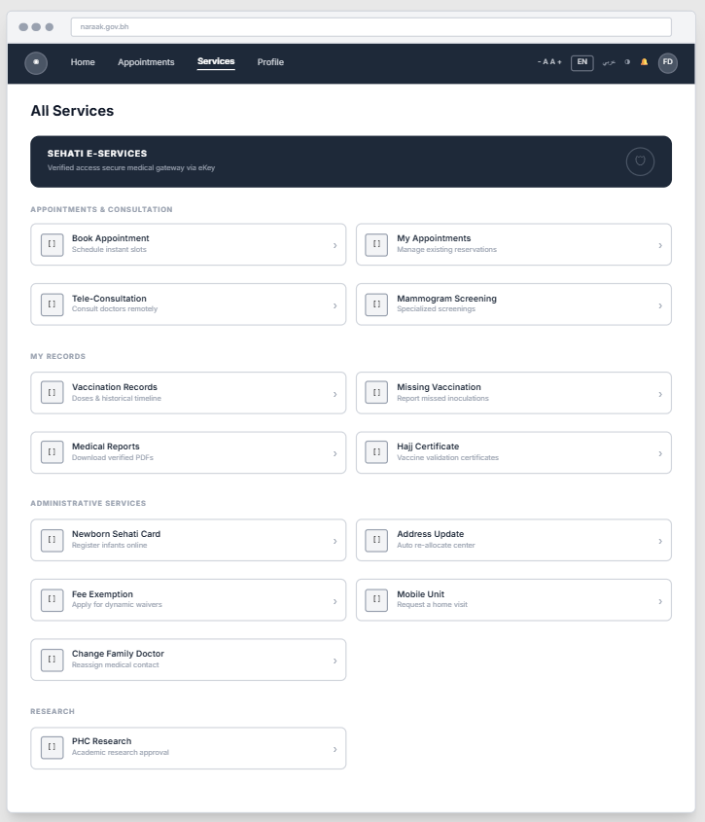
Figure 45: All Services Tab

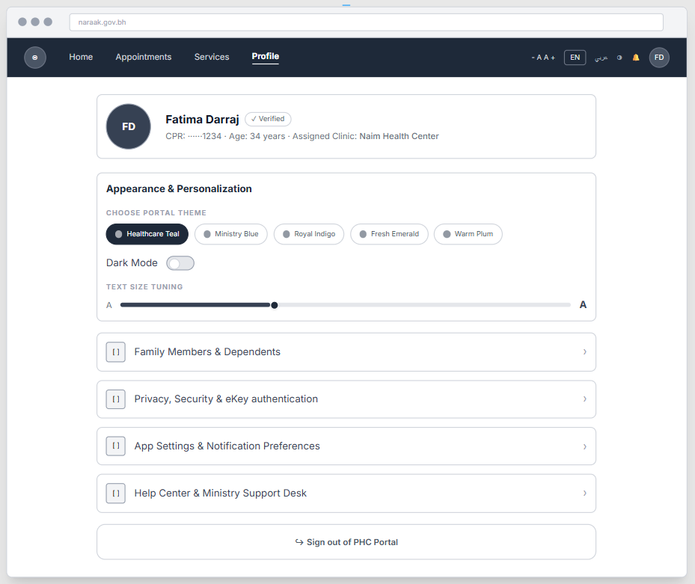
Figure 46: Profile Tab

Note: The web application mirrors the mobile app's information architecture, service flows, and user flows exactly as documented in Sections 2 of this report. Every service flow, user flow, and interaction pattern shown for mobile will applies identically to the web version. The Web Version section (Section 5.3) illustrates only the visual layout adaptation for a larger screen; it does not introduce any new flows, logic, or functionality beyond what is already specified for mobile.

6. Reference

Figma — Low-Fidelity Wireframes: https://www.figma.com/make/pjDKer8udro1ocbQWk09N9/low-fidelity-wireframes-Naraak--1-?t=3hSEYROdG4VM7K5W-1

Figma — Service & User Flows: https://www.figma.com/board/QNiHntX3ZGpgfPJRkxtwYD/Naraak--flows?node-id=0-1&t=SGGTaZqpTJD88Tuv-1

